Lab 5 : HATEOAS

* In order to use Spring Initilizr, go to [https://start.spring.io](https://start.spring.io/):
* 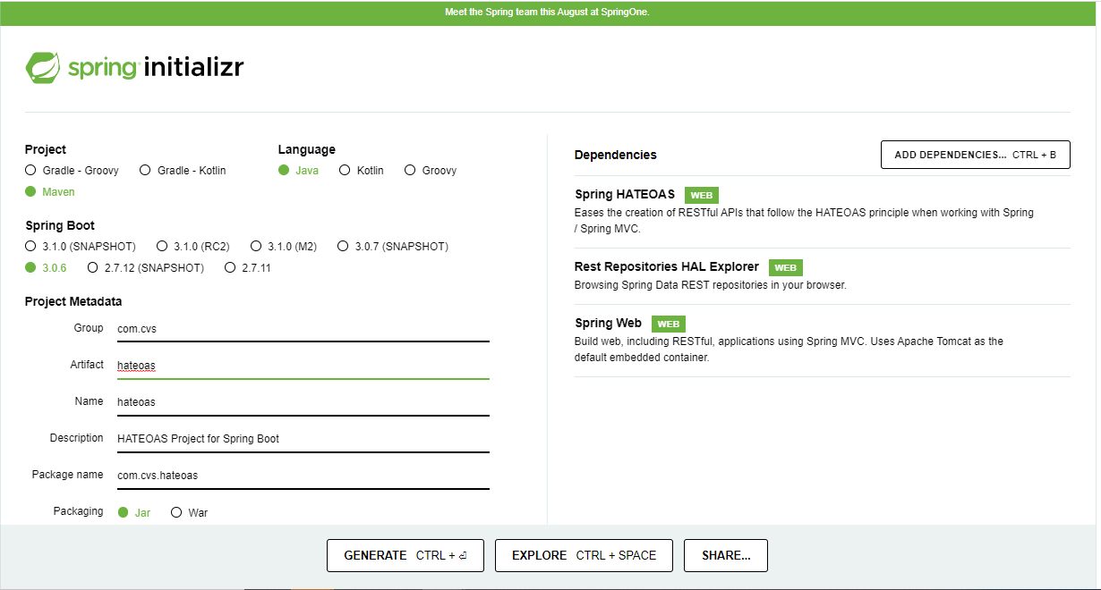
* Fill the details, such as whether it is a Maven project, Spring Boot version, group, and artifact ID, as shown earlier, and click on **Switch to the full version** link under the **Generate Project** button. Select **Web**, **HATEOAS**, and **Rest Repositories HAL Browser**. Make sure that the Java version is 17 and the package type is selected as **JAR**:
* Once selected, hit the **Explore** button. Finally, Download the project. This will generate a Maven project and download the project as a ZIP file into the download directory of the browser.
* Unzip the file and save it to a directory of your choice.
* You can also fork this github: <https://github.com/fenago/hateoas>
* Then call: <https://gitpod.io/#https://github.com/fenago/hateoas> (replace fenago with your github user id)
* 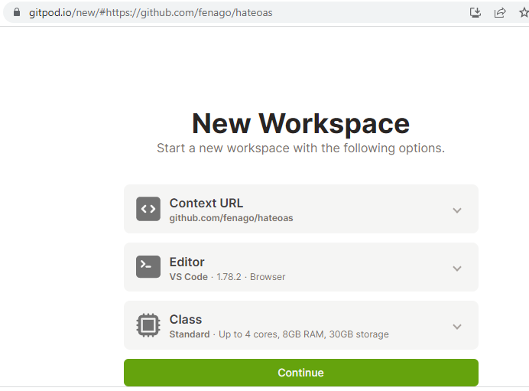
* Open your IDE, and start your development:
* Accept the plugins recommended and reload if requested.
* Edit the HateoasApplication.java file to add a new REST endpoint, as follows:
* @RequestMapping("/greeting")  
  @ResponseBody  
  public HttpEntity<Greet> greeting(@RequestParam(value = "name", required = false, defaultValue = "HATEOAS") String name) {  
   Greet greet = new Greet("Hello " + name);  
   greet.add(linkTo(methodOn(GreetingController.class).greeting(name)).withSelfRel());  
    
   return new ResponseEntity<Greet>(greet, HttpStatus.OK);  
  }
* 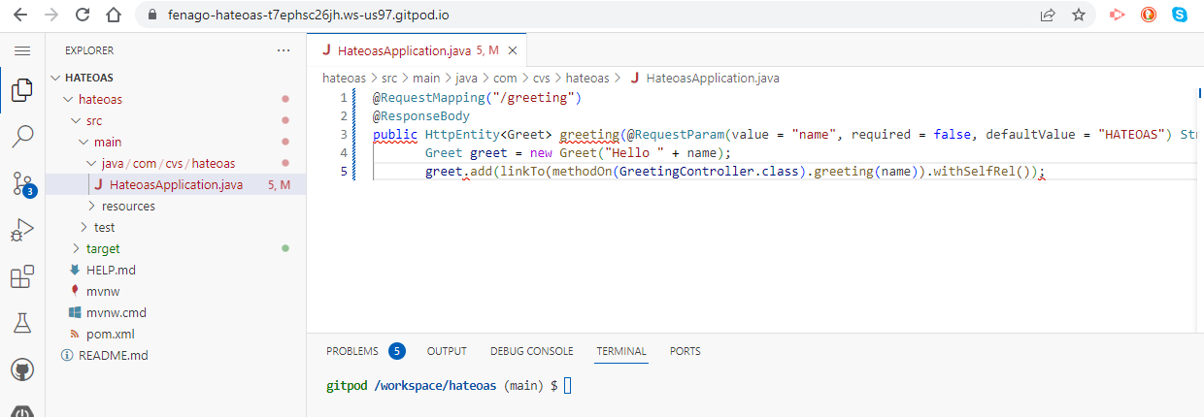
* Note that this is the same GreetingController class as in the previous example. However, a method was added this time named greeting. In this new method, an additional optional request parameter is defined and defaulted to HATEOAS. The following code adds a link to the resulting JSON code. In this case, it adds the link to the same API:
* greet.add(linkTo(methodOn(GreetingController.class).greeting(name)).withSelfRel());
* In order to do this, we need to extend the Greet class from ResourceSupport, as shown here. The rest of the code remains the same:
* class Greet extends ResourceSupport{
* The add method is a method in ResourceSupport. The linkTo and methodOn methods are static methods of ControllerLinkBuilder, a utility class for creating links on controller classes. The methodOn method will do a dummy method invocation, and linkTo will create a link to the controller class. In this case, we will use withSelfRel to point it to itself.
* This will essentially produce a link, /greeting?name=HATEOAS, by default. A client can read the link and initiate another call.
* Run this as a Spring Boot app. Once the server startup is complete, point the browser to http://localhost:8080.
* This will open the HAL browser window. In the **Explorer** field, type /greeting?name=World! and click on the **Go** button. If everything is fine, the HAL browser will show the response details as shown in the following screenshot:
* 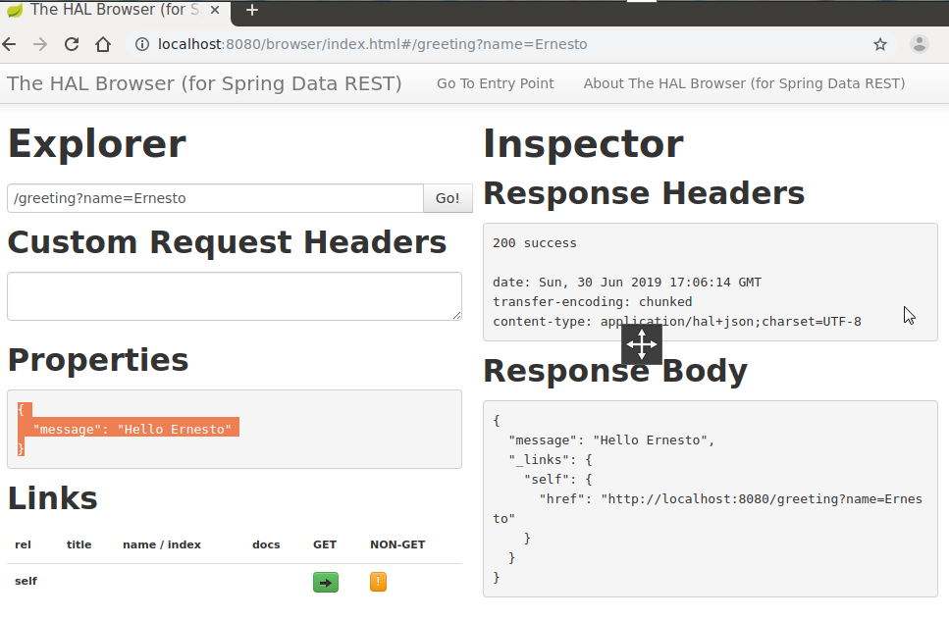

As shown in the screenshot, the **Response Body** section has the result with a link with href pointing back to the same service. This is because we pointed the reference to itself. Also, review the **Links** section. The little green box against **self** is the navigable link.

It does not make much sense in this simple example, but this could be handy in larger applications with many related entities. Using the links provided, the client can easily navigate back and forth between these entities with ease.